ATTENTION

The human memory is ‘limited’ or constrained.

Moreover, people are constantly bombarded with images, sounds, smells, tastes and touch.
Computer systems should be designed with that understanding.

Attention links closely with our short-term memory or working memory.
The ability to manipulate information we work with involves a mutual effort between turning our attention onto something and also keeping those units of information in our working memory.
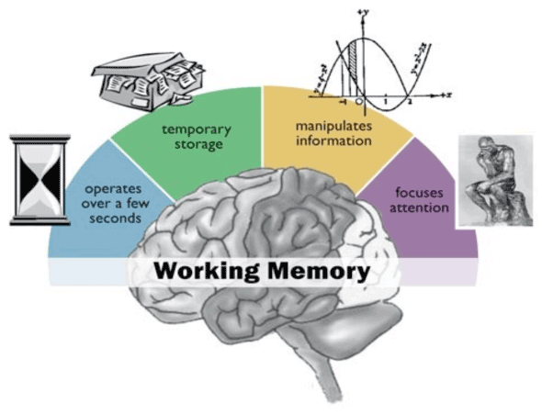
Question: What is the cocktail-party effect?

Attention can be focused or divided:
- Focused attention: this is the ability to attend to one event/object from what amounts to a mass of competing stimuli in the environment.
- Divided attention: this is the ability to attend to more than one event/object at the same time.

Focusing attention at the user interface

Techniques that can be used to direct the user’s attention to the relevant information on the user interface include:
- Structuring information
The user interface should be structured so that it is easy to navigate through.
This also includes aspects such as: size, bold, underlining, circling,
Moreover, it requires that the data on the user interface be grouped and ordered into meaningful parts. For instance: the Gestalt laws of perceptual organization (recall) can make information easier to perceive.
- Spatial and temporal cues
- Colours and images
- Alerting techniques e.g. animation, flashing, audio, pop ups, etc.
- Incorporating/engaging many senses simultaneously
- Using pointing tools

Some guidelines in using the above attention techniques:
- Important information which needs immediate attention should always be displayed conspicuously or in a prominent place to catch the user’s attention.
- Less urgent information that is needed should be allocated to less prominent but specific places of the screen.
- Information that not needed very often should not be displayed but availed on user’s request.

